
2026 Victoria Highland Games Volunteer Orientation

Thank you for volunteering for the Victoria Highland Games and Celtic Festival! We are thrilled to have you on the team! Being well prepared will help you enjoy this volunteer experience. Please take a moment to go through this document and familiarize yourself with the map of the grounds and volunteer information.

GROUNDS MAP ………………………………………….………………………………...……………………………….………………...........……2
CODE OF CONDUCT 3
PARKING 3
VOLUNTEER ENTRANCE 3
LUNCH, BEVERAGE & SNACK 4
WASHROOMS - Portable washrooms will be available in numerous locations around the park. 4
FIRST AID - 4
LOST & FOUND - Lost & found will be located at the Volunteer / Information / Lost & Found Tent. 4
LOST CHILD PROCEDURE 4
VOLUNTEER ROLES………………………………………………………………………………………………………………………...…………….5
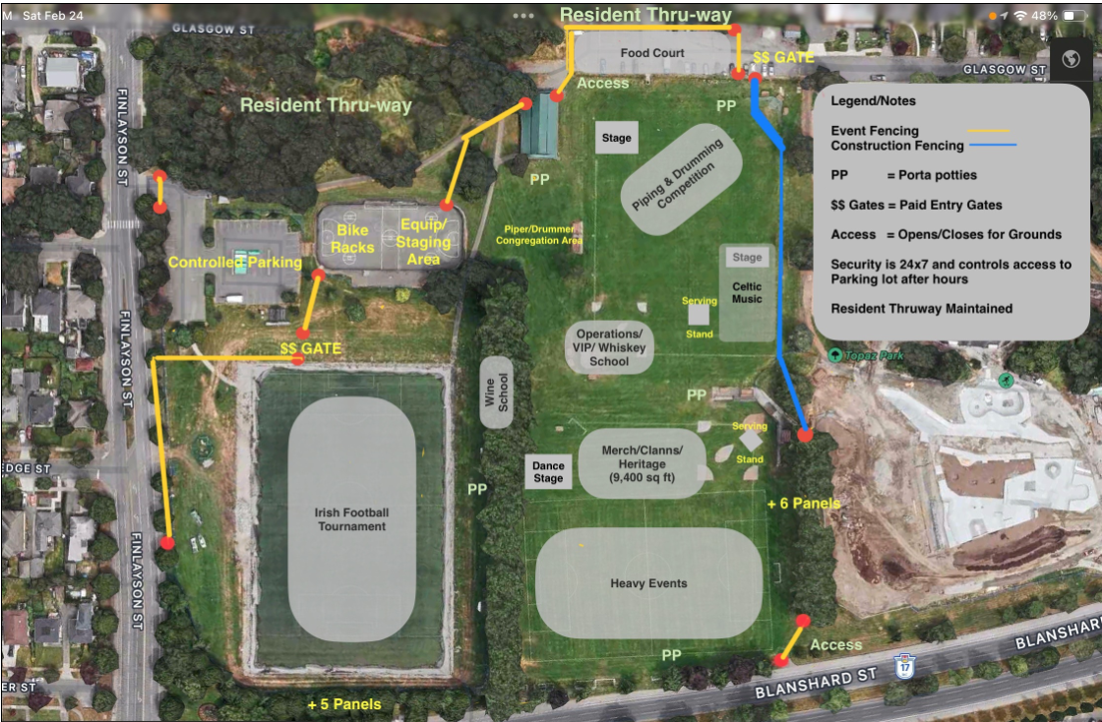

CODE OF CONDUCT
For the Games to run smoothly and efficiently, it’s important for everyone to understand and follow a few simple rules:
- No friends/spouses/children/others can accompany volunteers during their shifts (unless they are registered volunteers as well)
- Volunteers must complete their FULL shift. Shifts overlap by 15 to 30 minutes for cross training. Please stay and mentor or cross-train the next person, and please remain to the end of your shift to help your fellow clansmen.
- No smoking in Topaz Park
- No dogs, except Registered Guide Dogs allowed in Topaz Park for everyone’s safety. Loud noises are common.
- No alcohol consumption allowed during your shift. Please remove your Volunteer shirt when attending the Beverage Gardens.
- Keep your phone in your bag or pocket on mute – focus on your role, and be a Games ambassador.
- If you are unable to fulfill your shift, let us know as soon as possible! Sign into Sign Up Genius (via the link below) and remove your volunteer slot: Website: https:\\volunteer@victoriahighlandgames.com up to 2 days before the games. Email….
- If Registration is closed (and the link is inactive), please e-mail: volunteer@victoriahighlandgames.com and let Lily (Volunteer Supervisor), or Caleen (Volunteer Coordinator) know of your issue up to 16 hours before the games. After Friday, May 16th at noon, please call or text Caleen’s cell number at 778-678-5592.

By agreeing to volunteer with the Games, you are representing our organization to the public and are expected to be courteous and helpful to those enjoying the Games. With your help and cooperation, it will be another amazing year!

PARKING
Free Parking is available at SJ Willis Alternative School, Hillside Field or on any street near Topaz Park. Be aware some parking is only offered for 2 hours at a time. Please respect the residents who live near the park and do not block driveways or walkways. Our ambassadors have been out in the neighbourhood alerting them to the presence of the Games. Hopefully, parking will not present an issue.

VOLUNTEER ENTRANCE
All volunteers, except those who are scheduled to start at 7:00 am, are asked to please arrive at the Games at least 15 minutes prior to your shift to allow time to enter, register and make your way to the volunteer post.

- Enter the grounds at Finlayson Street Gate and tell them you are a volunteer.

- Come to the VOLUNTEER REGISTRATION TENT, just inside the Finlayson entrance. Give them your name and picture ID to receive your entry wristband, meal coupon(s), T-Shirt and information.

- Please wear your volunteer T-Shirt only while you are actively in your volunteer post and remove it when you have completed your volunteer shift. We have a changeroom and storage facility at the Volunteer Refuge Tent, across from the Volunteer Tent on Finlayson. Or, your bag or backpack can be stowed beneath the table at your volunteer post.

- You are asked not to bring valuables to the games as we cannot be responsible for lost/missing items.

- Bring picture ID for sign-in at the Volunteer Tent, as well as stowing and retrieving your gear at the Refuge Tent. If you intend to partake in the Beverage Gardens (after your shift), picture ID is REQUIRED, regardless of your age.

- Dress for the weather. This event will go on rain or shine, so please be prepared. The weather changes dramatically from year to year, so check the weather forecast and assume variable conditions. At a minimum, bring a shell for a raincoat in your backpack, and sunscreen. Normally, both are required.

- We recommended that you bring water, a nutritious snack, sunscreen, lip protection, sunglasses, a hat, a light waterproof / windproof / hooded jacket, and warm to cool / layered clothing. This includes something you can wear under your volunteer T-Shirt, particularly if it is cold and/or windy.

- Please plan to cover your volunteer t-shirt, or change, while off-duty inside the Games’ grounds at Topaz Park.

LUNCH, BEVERAGE & SNACK
When you sign in for your shift(s), you will receive your food and beverage coupon. This coupon will provide food and a drink at the Lion’s Volunteer Lunch Tent. People with two or more shifts per day will also receive a Granola Bar snack.
If you are doing back-to-back shifts, coordinate with other volunteers to take a 15-minute break to eat, but please ensure there are always enough people remaining on shift. Work with your coordinator to ensure this.

WASHROOMS - Portable washrooms will be available in numerous locations around the park.

FIRST AID - On site, usually on the hill above the Heavy Events or near the Highland Dance Competition. Contact security via radio if someone needs transport or attendance at another location.

LOST & FOUND - Lost & found will be located at the Volunteer / Information / Lost & Found Tent.

LOST CHILD PROCEDURE
If someone approaches you to say that their child is missing, find the nearest Security Guard, or bring them to the Volunteer / Information / Lost & Found Tent located next to the Finlayson Gate where security will be alerted by radio.

VOLUNTEER ROLES

Beverage Server (must be 19+ with Serve It Right certification provided) – Volunteer Contact: Caleen Taylor
Open canned liquor beverages at beverage gardens.

Beverage Ticket seller and/or ID checker (must be 19+) – Volunteer Contact: Caleen Taylor
Sell drink tickets, handle cash and Clover (point of sale from Fiserv); OR check ID and put on wristbands.

Celtic Music Assistant – Volunteer contact: Graham Duffel
Sell CDs, tidy chairs, assist band set up and take down.

Clan Area Assistant – Volunteer contact: Troy More
Assist the Clans Area Chair and Representatives with set up - tents, tables, chairs, and displays.

Clan Info Assistant – Volunteer contact: Troy More
Provide Clan information. Strong English language essential and strong understanding of Scottish geography and history an asset.

Dance Competition – Volunteer contact: Megan McKenzie (Dancers enter free; parents must pay for entry)
- Sign Changer – Change the signs on the Dance Competition stage for each new dance.
- Dance Marshalling – Dancer lineup. Adults familiar with Highland Dance competitions preferred.
- Dance Scoring and Numbers – Provide numbers to entrants; enter scores into computer.

Gate Positions – Volunteer contact: Cara Temmel
- Ticket booths (all gates) – Receive money, give change; use Clover (point of sale from Fiserv).
- Advance / Eventbrite Tickets – Accept or scan advanced tickets.
- Outside Facilitators – Organize lineup, answer entry or gate-related questions.
- Whisky School Tickets – Verify and count.
- Check Entry & Exit Wristbands – Check coloured wristbands and manage gate traffic flow.

Heritage Hub Assistant – Volunteer contact: Michael Elcock
Assist the Heritage Hub Chair and presenters with table, chair, audio-visual equipment, and display setup. Manage traffic flows. Learn about Scottish heritage while you volunteer!

Merchandise Sales Assistant – Volunteer contact: Kristina Stewart
Sell Highland Games official clothing and souvenirs; handle cash $$$ and Clover (point of sale from Fiserv)

Volunteer Sign-In, Information & Lost & Found Tent – Volunteer Chair: Caleen Taylor
Check in volunteers, distribute T-Shirts, lunch coupons, and wristbands, answer questions from the public, manage lost and found items.

Volunteer Refuge Tent – Volunteer Chair: Caleen Taylor
Guard and maintain Volunteer storage, lunch, and change facility. Sign backpacks in/out. Act as a Volunteer resource or guide. Keep area tidy.

Questions? Email: volunteer@victoriahighlandgames.com
Board Chairs at https://victoriahighlandgames.com/vhga-association/executive/

To connect with any of the Venue Coordinators, or Board Chairs go to:
https://victoriahighlandgames.com/vhga-association/executive/

